Seeking to cure the incurable
March 10, 2015 | Last Updated: Mar 10 6:40 AM ET
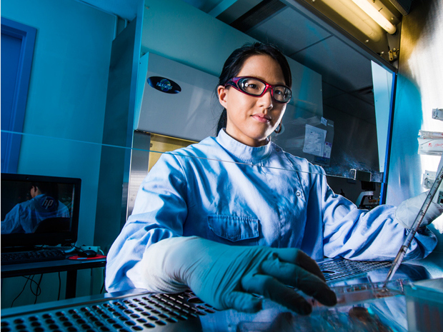
Canada and Japan setting the world pace for innovations in regenerative medicine
Canada and Japan are taking distinctly different but complementary paths in the development of a regenerative medicine industry within their borders. While their paths may differ, their activities are having a profound impact on the future of a global industry that is poised for exponential growth.
Japan’s commitment to regenerative medicine leadership has been fuelled by Prime Minister Shinzo Abe’s vision for revitalizing the country’s economy. That economic revival includes policies to support the development of a robust, world-leading regenerative medicine industry in Japan, including US$1-billion in funding for stem cell research over 10 years.
While the Japanese initiatives are in part driven by national economic interests, they are fundamentally about bringing new medicines to a significantly and rapidly aging Japanese demographic.
“Japan is looking to establish leadership in the regenerative medicine industry by encouraging domestic innovation and enticing foreign companies to develop products in Japan by bringing foreign therapeutics to the Japanese market,” says Shinichi Muto, chief Japan representative for Euro Pacific Canada, Inc. “The mission of our nation’s leadership is to pave the way for real, practical breakthroughs in regenerative medicine. My firm is actively working with companies outside Japan, like RepliCel Life Sciences and others, to build three-way partnerships between Japanese investors, strategic partners, and therapeutic developers.”
“The regenerative medicine and cell therapy field is changing rapidly around the world,” says Michael May, chief executive officer of the Centre for Commercialization of Regenerative Medicine (CCRM) in Toronto. “What is happening in Japan is one example of how momentum is building in this industry. Corporate, technological, financial and clinical developments are happening very, very quickly.”
Regenerative medicine aims to harness the power of cells, biomaterials and molecules to repair, regenerate or replace diseased cells, tissues and organs. It has the promise to treat, manage and perhaps cure some of the most devastating and costly diseases or chronic conditions in the world today.
A key component of Japan’s strategy is changing the regulatory policy around the oversight, approval, clinical development and manufacturing processes related to cell-based therapies. “For those in the industry, this is a leading initiative that promises to dramatically change the regenerative medicine landscape,” May says. “Japan is revolutionizing regulatory approval in order to become a ‘stem cell nation’.”
Canada has its own leadership role to play in terms of its strength in regenerative medicine science, he adds. “Canada has some very novel and valuable strategies in play around regenerative medicine that will benefit immensely in light of Japan’s movement.”
CCRM is playing a key role in commercializing the wealth of regenerative medicine science and intellectual property available in Canada. This is being achieved either by establishing new companies or finding partners to develop technologies on their behalf. Since its inception in 2011, CCRM has established ties with academia, created a formal industry consortium of more than 40 companies from around the world, and gained six core Canadian institutional partners.
Consortium members representing key sectors of the regenerative industry include the McEwen Centre for Regenerative Medicine, a world-renowned centre for stem cell biology and regenerative medicine to treat conditions such as heart disease, diabetes, respiratory disease and spinal cord injury. Canada is also home to the Canadian Stem Cell Network, one of the most prodigious producers of pre-clinical stem cell research and publications.
CCRM to date has performed due diligence on 200 cell therapy technologies from Canada and around the world. These include work by Canadian leaders such as Induce Biologics, Sernova, TRT, RepliCel Life Sciences, Insception Lifebank, Octane, Northern Therapeutics, Interface Biologics, Stemcell Technologies, Actium Research, Hemostemix and more.
Now the focus is on building a third network, which is one of investors, May says. “The plan is to launch investment vehicles specifically focused on regenerative medicine to finance commercial opportunities in Canada. This final piece is really important in supporting commercialization and creating manufacturing capability in Ontario. When this happens, Canada will hold a unique leadership position in the world.”
CCRM is a world-class example of the efforts to create pathways for regenerative medicine commercialization, says Lee Buckler, vice-president, business and corporate development, for RepliCel Life Sciences (TSXV: RP) in Vancouver. “They are really bringing the whole industry to Canada by creating an infrastructure for great research, development, production and commercialization.”
RepliCel is a regenerative medicine innovator that has been among the first in the world to create formal ties with Japanese industry to leverage this rapidly emerging opportunity. In 2013, it signed a major deal with Shiseido Company for commercialization of its autologous cell therapy (produced using cells harvested from the patient’s own hair follicles) for treating pattern baldness. The agreement granted an exclusive license for RepliCel’s most advanced product, RCH-01, to Shiseido for certain Asian countries.
Youichi Shimatani, Shiseido’s chief corporate officer for research and development, says “Creating beauty in everyday life is the mission of Shiseido. To alleviate suffering of people with alopecia, we have dedicated many years to hair research. Using the knowledge and technologies acquired from our research activities, Shiseido is currently preparing to launch an RCH-01 clinical research study for the treatment of pattern baldness under the supervision of key clinical opinion leaders of hair research in Japan.” In his opinion, “Japan’s new regenerative medicine law allows industry partners like Shiseido to take part in clinical research under clinical guidance to develop new regenerative therapies. We hope that our efforts will lead to further promotion and advancement of regenerative medicine in Japan.”
RepliCel holds a unique and strong competitive position in Japan, Buckler notes, because the deal with Shiseido was signed shortly before Japan’s new regulations were finalized in November 2014.
He says RepliCel ranks as one of the few foreign cell therapy companies with a Japanese partner, and one of an even smaller group with an active manufacturing footprint in Japan. “We believe we are also one of the first foreign cell therapy companies poised to initiate a clinical trial with its Japanese partner under the new regulations.”
The company is also actively engaged with investors and potential partners to establish similar partnerships for other products in its pipeline for orthopedic (tendon repair) and dermatological (skin rejuvenation) applications.
Buckler believes Canada’s deep roots in regenerative medicine, combined with the collaborative efforts on the part of CCRM, bode well for the prospects of companies such as RepliCel that are pursuing global commercialization opportunities.
While Japan is not the sole focus of CCRM’s global collaboration efforts, May says it is a cornerstone to Canada’s future as a leader in regenerative medicine. “One of the most revolutionary things Japan has done is create new pathways for regenerative medicine that allow cell therapy companies to get conditional approval and bring their product to market more quickly. Expediting market access has created a tremendous motivation for companies to bring technologies into Japan for development and commercialization. Investors for their part see the same opportunity and are looking for ways to build on this momentum.”
This momentum is indicative of the interest being generated in investment in cell therapy research globally, May says. “CCRM’s networking efforts with other global centres of excellence, and new regulatory pathways in countries such as Japan, are wonderful examples of how firms are working in multiple jurisdictions to bring potentially life-saving products to market.”

